**Show website:**

Enplaning the idea about how customer interact with the website.

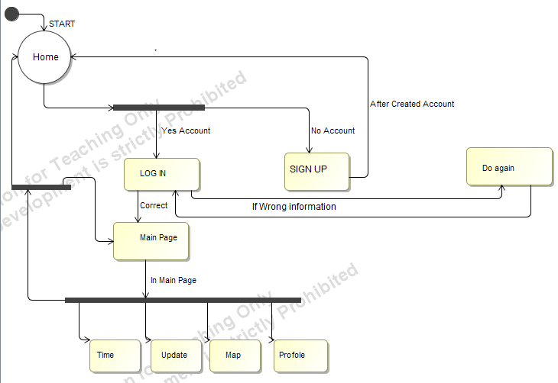

* Customer can create a new account by clicking the **Sign Up** button**.**
* Update the account information by clicking the **Manage** menu panel.
* Customer can check the time schedule and price table.
* Customer can check his/her account information.
* Customer can also check the transportation map.

**Show interaction between client, trainserver, and main server using dev GUI.**

* Explaining the idea for connecting and disconnecting clients:

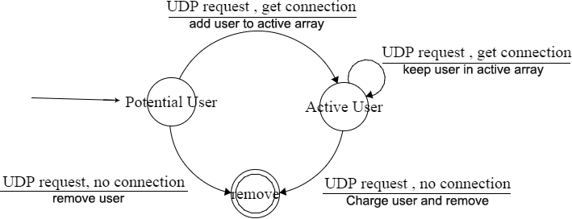

* Sending out UDP multicast to multiple clients and having them connect to the train server.
* Getting the information about each user from the main server as one request packet, seen in the NetBeans log window.
* Assigning all clients to the potential clients array.
* Next UDP cast assigns all old clients to active users.
* Removing users from the trainserver.
* Showing a user's charge after being removed.

Show Unit Tests:

* DatabaseHandler test, adding, updating, deleting users and building traffic network graph.
* Pathfinding. Finding the shortest path in a network of test nodes with randomly generated edges.